**TASK 7:** **Identify and Remove Suspicious Browser Extensions**

1. **Open your browser’s extension/add-ons manager.**

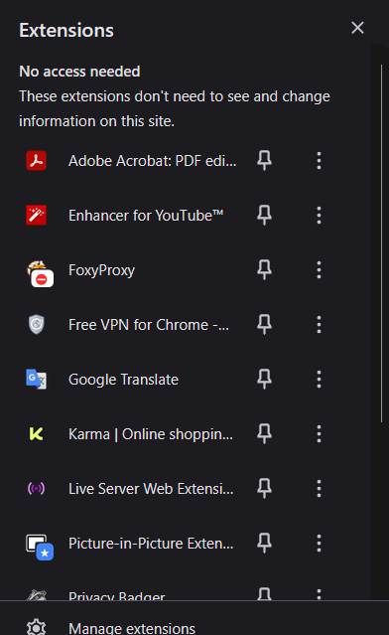

This is the list of extensions which I have installed in my web-browser.

1. **Review all the extensions carefully.**

I checked all the extensions which are added in my browser. There is no suspicious or any harmful extension found.

1. **Check the permissions which are given to the extensions.**

There are mostly extensions related to the AdBlocker, Translation, picture in picture mode, VPN, wappalyzer etc.

They all hold the permission of the sites which I visit to perform their task and functions.

1. **Identify the unused and suspicious extension.**

There is no such extension which is unused and suspicious because I keep my extension list updated and upgrading into latest ones.

1. **Research of how malicious extensions harm the users**

There are many harms which can be caused by the malicious extensions:

* Stealing Personal Information
* Spying on Browsing Activity
* Injecting Ads and Redirects
* Installing Additional Malware
* Hijacking Social Media or Email
* Disabling Security Settings
* Cryptocurrency Theft or Cryptojacking
* Persistent Access